- Create an HTML form for a Flipkart-style product review, including input fields for username, rating (as a dropdown from 1 to 5), and a textarea for the review message. Use appropriate labels for each field.
- <h2>Flipkart Product Review Form</h2>

- <form>

- <label for="username">Username:</label><br>
- <input type="text" id="username" name="username"><br><br>

- <label for="rating">Rating:</label><br>
- <select id="rating" name="rating">
- <option value="">Select Rating</option>
- <option value="1">1 - Poor</option>
- <option value="2">2 - Fair</option>
- <option value="3">3 - Good</option>
- <option value="4">4 - Very Good</option>
- <option value="5">5 - Excellent</option>
- </select><br><br>

- <label for="review">Review Message:</label><br>
- <textarea id="review" name="review" rows="5" cols="40" placeholder="Write your review here..."></textarea><br><br>

- <input type="submit" value="Submit Review">

- </form>

2. Add HTML5 validation attributes to your review form so that username is required, rating must be selected, and the review message must be at least 20 characters long.<br><br><em><strong>Hint:</strong> Use required, minlength, and a default unselectable option for the dropdown.</em>
<h2>Flipkart Product Review Form</h2>

<form>

<label for="username">Username:</label><br>
<input type="text" id="username" name="username" required>
<br><br>

<label for="rating">Rating:</label><br>
<select id="rating" name="rating" required>
<option value="" selected disabled>Select Rating</option>
<option value="1">1 - Poor</option>
<option value="2">2 - Fair</option>
<option value="3">3 - Good</option>
<option value="4">4 - Very Good</option>
<option value="5">5 - Excellent</option>
</select>
<br><br>

<label for="review">Review Message:</label><br>
<textarea
id="review"
name="review"
rows="5"
cols="40"
minlength="20"
required
placeholder="Write at least 20 characters..."></textarea>
<br><br>

<input type="submit" value="Submit Review">

</form>

3. Modify your form to use the POST method and, after submitting a test review, open the DevTools Network tab to preview the POST request data sent by your form.<br><br><em><strong>Hint:</strong> Look for the form submission request and expand the payload/details to see your input values.</em>
<h2>Flipkart Product Review Form</h2>

<!-- Make sure your form tag looks like this -->
<form action="https://httpbin.org/post" method="POST">
<!-- Your review inputs (e.g., name, rating, comment) go here -->
<label for="reviewerName">Name:</label>
<input type="text" id="reviewerName" name="username">

<label for="reviewText">Review:</label>
<textarea id="reviewText" name="review_content"></textarea>

<button type="submit">Submit Review</button>
</form>

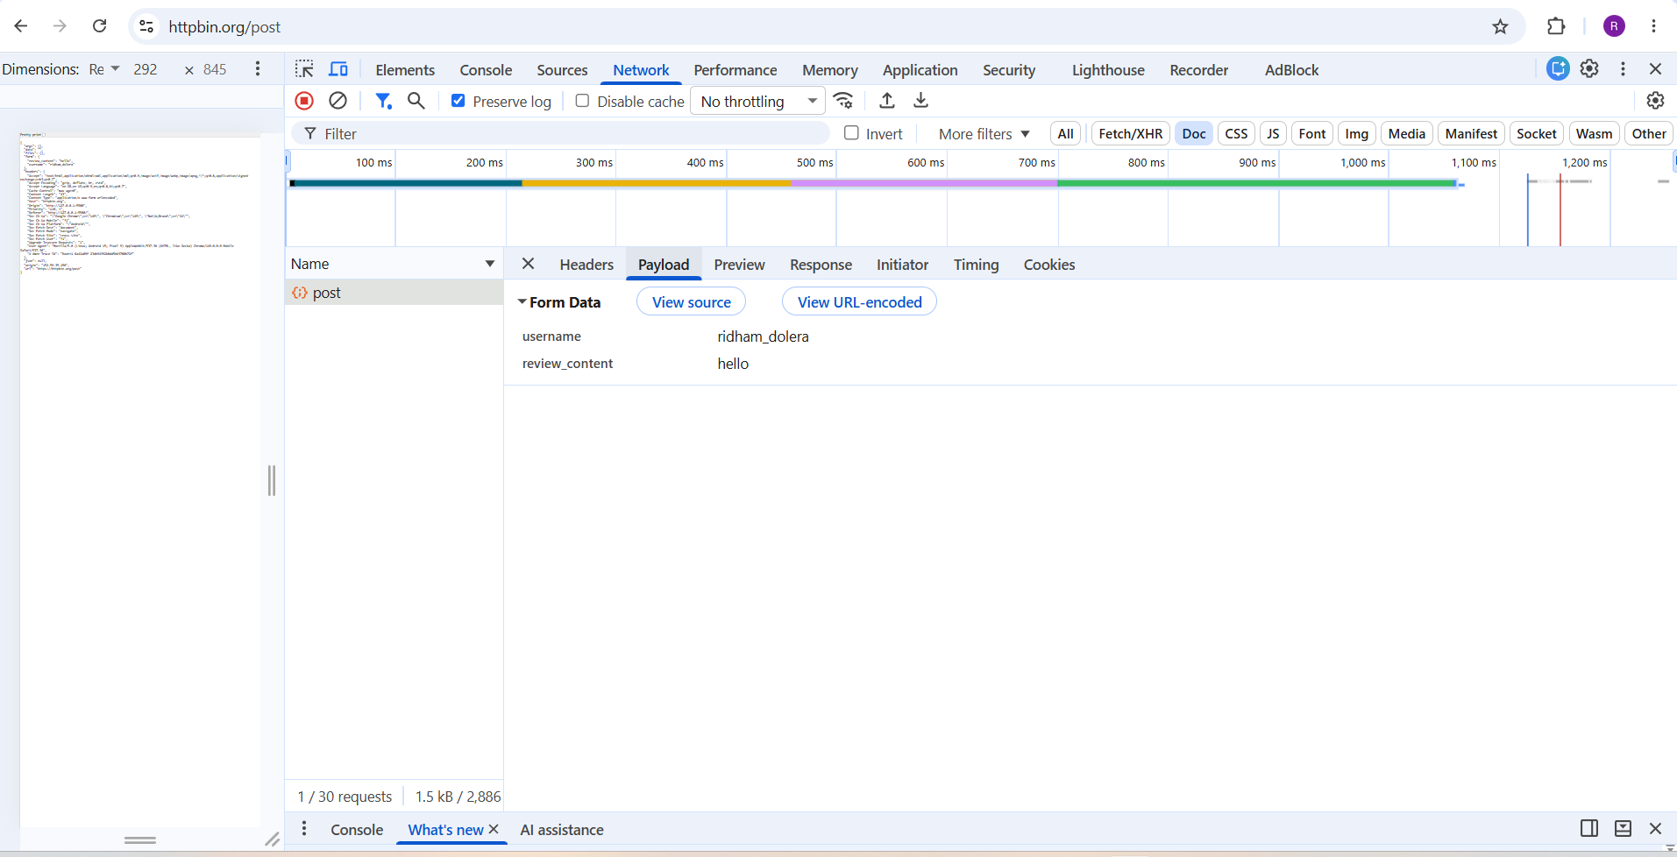
4. Build a Zomato-style food order form with inputs for user name, a select dropdown for food item (at least 3 options), quantity (number input), and a textarea for delivery instructions. Ensure all fields are labeled and use required validation.
<!DOCTYPE html>
<html lang="en">
<head>
<meta charset="UTF-8">
<meta name="viewport" content="width=device-width, initial-scale=1.0">
<title>Zomato Food Order Form</title>

<style>
*{
margin:0;
padding:0;
box-sizing:border-box;
font-family:Arial, Helvetica, sans-serif;
}

body{
background:#f8f8f8;
display:flex;
justify-content:center;
align-items:center;
min-height:100vh;
padding:20px;
}

.order-form{
width:100%;
max-width:500px;
background:#fff;
padding:30px;
border-radius:12px;
box-shadow:0 8px 20px rgba(0,0,0,0.15);
}

h2{
text-align:center;
color:#e23744;
margin-bottom:25px;
}

.form-group{
margin-bottom:20px;
}

label{
display:block;
margin-bottom:8px;
font-weight:bold;
color:#333;
}

input,
select,
textarea{
width:100%;
padding:12px;
border:1px solid #ccc;
border-radius:8px;
font-size:16px;
transition:0.3s;
}

input:focus,
select:focus,
textarea:focus{
outline:none;
border-color:#e23744;
box-shadow:0 0 6px rgba(226,55,68,0.3);
}

textarea{
resize:vertical;
}

button{
width:100%;
padding:14px;
background:#e23744;
color:#fff;
border:none;
border-radius:8px;
font-size:17px;
cursor:pointer;
transition:0.3s;
}

button:hover{
background:#c62839;
}
</style>
</head>
<body>

<div class="order-form">

<h2>Zomato Food Order</h2>

<form action="#" method="post">

<div class="form-group">
<label for="username">User Name</label>
<input
type="text"
id="username"
name="username"
placeholder="Enter your name"
required>
</div>

<div class="form-group">
<label for="food">Food Item</label>
<select id="food" name="food" required>
<option value="">-- Select Food Item --</option>
<option value="Pizza">Pizza</option>
<option value="Burger">Burger</option>
<option value="Biryani">Biryani</option>
<option value="Pasta">Pasta</option>
<option value="Sandwich">Sandwich</option>
</select>
</div>

<div class="form-group">
<label for="quantity">Quantity</label>
<input
type="number"
id="quantity"
name="quantity"
min="1"
max="20"
placeholder="Enter quantity"
required>
</div>

<div class="form-group">
<label for="instructions">Delivery Instructions</label>
<textarea
id="instructions"
name="instructions"
rows="4"
placeholder="Enter delivery instructions..."
required></textarea>
</div>

<button type="submit">Place Order</button>

</form>

</div>

</body>
</html>

5. Add a disabled input field to your food order form that displays a fixed order ID (e.g., ORD12345) and explain in a comment why this field should be disabled for users.
<!--
The Order ID is generated by the system and should not be editable by users.
Using the disabled attribute prevents users from modifying this fixed value.
-->

<div class="form-group">
<label for="orderId">Order ID</label>
<input
type="text"
id="orderId"
name="orderId"
value="ORD12345"
disabled>
</div>

